**Name: Session:**

**Programming II**

**Lab Exercise 4.1.2024**

You may create this application using either a console application of a Windows form. You may copy my design, or create your own.

1. Create an application that generates 50 values and stored an array. The application should then display the largest and smallest values stored in the array. Your values should be in the range of 1 and 1000.

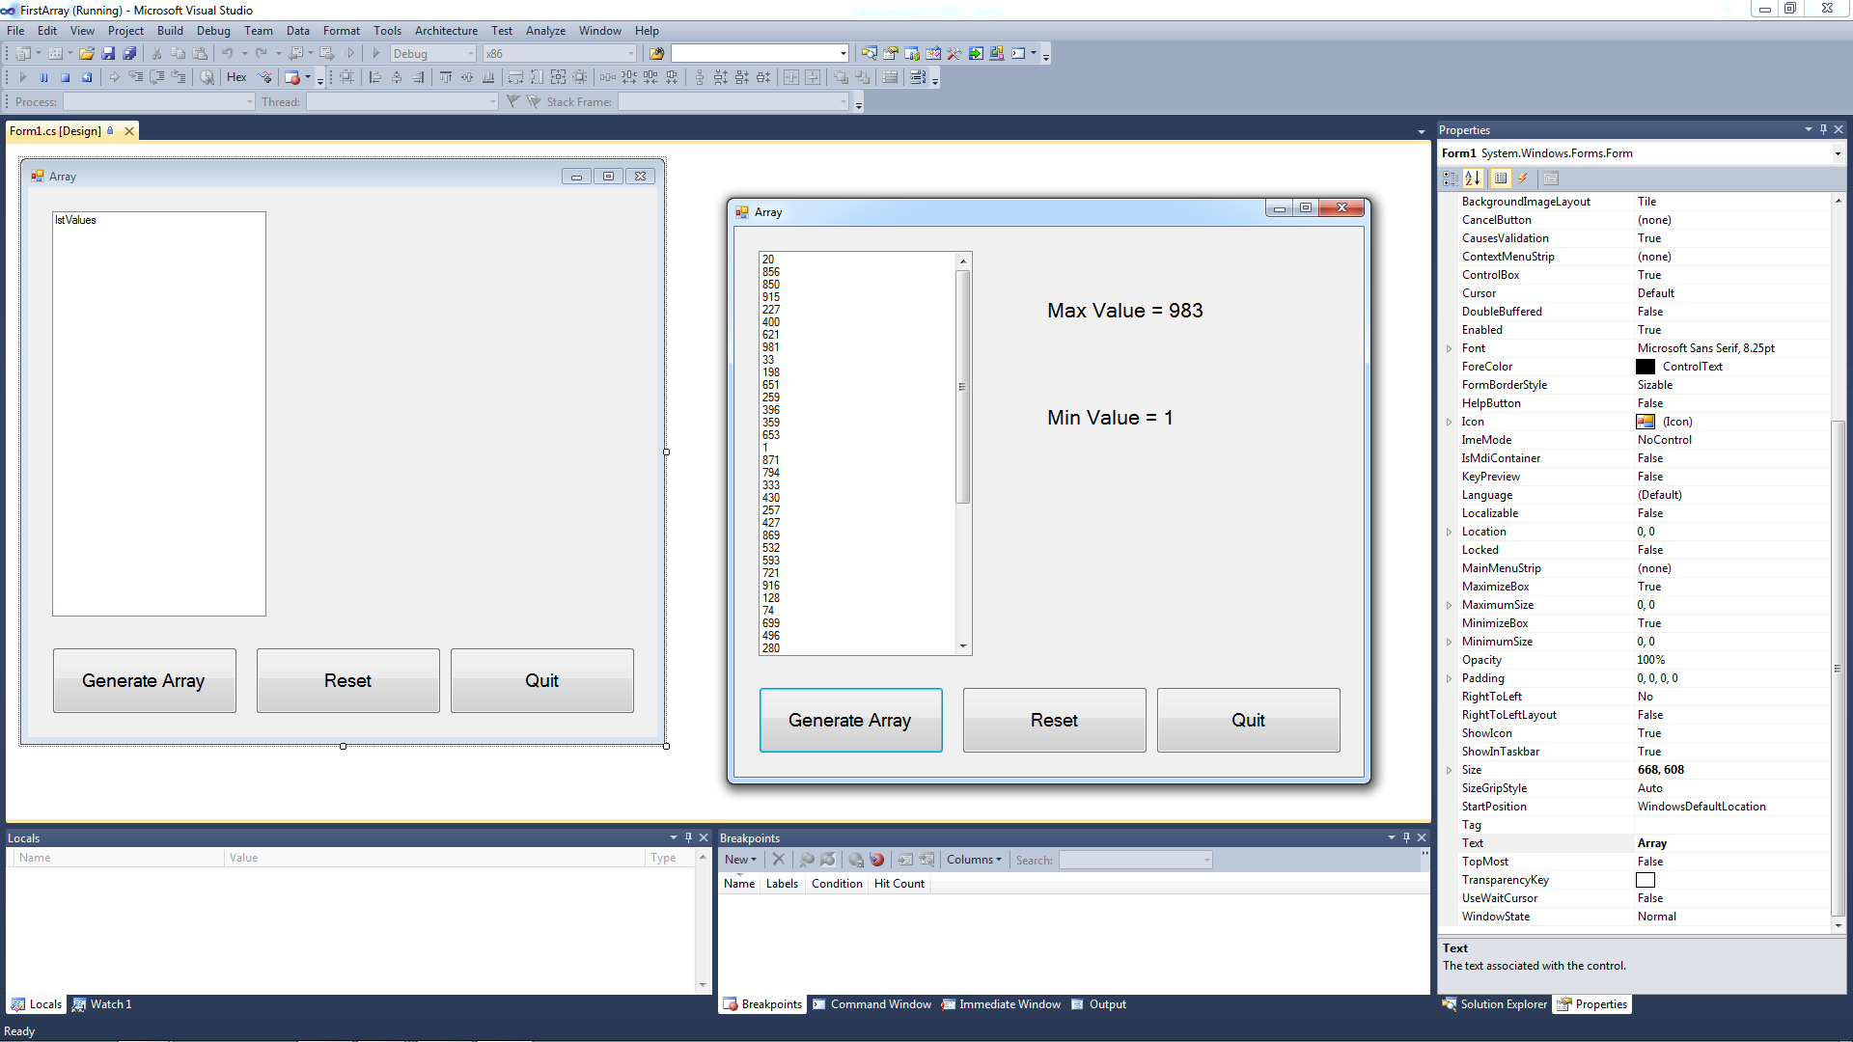

1. Create an application that generates rainfall data for each of 12 months into an array. The application should calculate and display the following statistics: total rainfall for the year, average monthly rainfall, and the months with the highest and lowest rainfall. Monthly rainfall should be in the range of 3 to 13 inches.

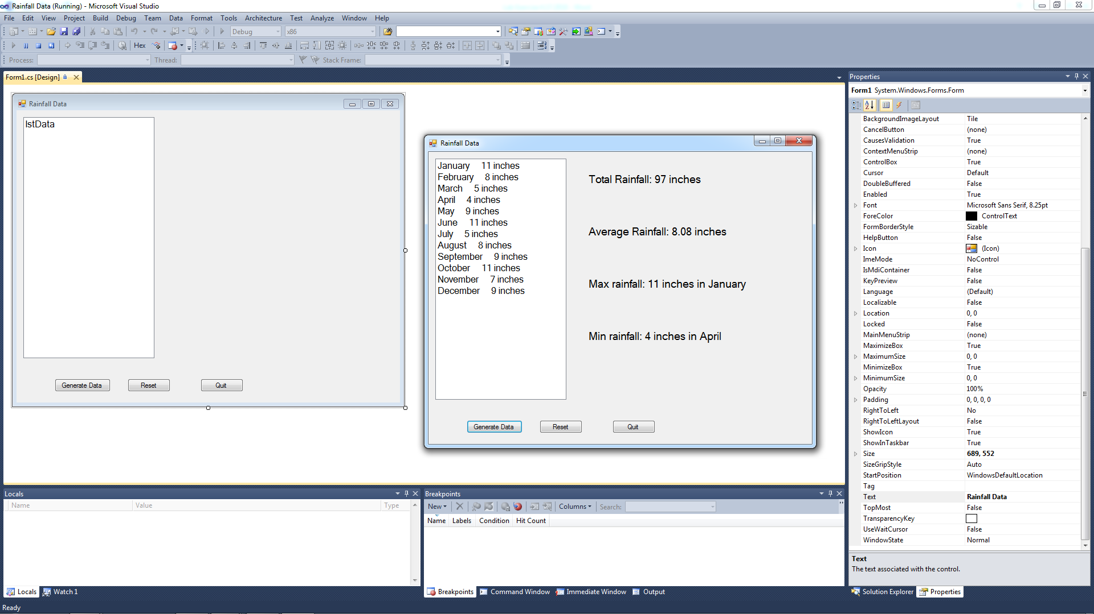

**When you complete your application, submit a screenshot of your running program.**